Hello Stas,

Vijay and I have worked through the program several days now and we have encoutered some problems and have quit a view remarks and wishes. We have worked through the tabs “RECIPE INITIAL” and “RECIPE DETAILED”. We got stuck in the RECIPE DETAILED. Most of our request are related to the present functionality of Eclipse, at least for those we frequently use.

Requests regarding RECIPE INITIAL:
- Please rename RECIPE INITIAL to RECIPE OVERVIEW
- In selector: Please rename DETAILED GROUP to POLYMER GROUP
- In selector: Please rename MIXER CODE tot MIXER
- In selector: Please add CUSTOMER
- In selector: Please facilitate in ingredients to select between AND/OR (select on one of both ingredients or on both ingredients)
- In selector: Regarding tot STATUS and CLASS: Now we can select a status or class, but we need also to unselect (avoid) a status or class. Therefore we suggest to make checkboxes for all the different statuses and classes
- In selector: When opening ingredients picklist, recipes appear. Here, the list ofingredients should appear.
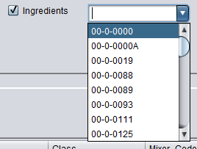

- In selector: When opening the ingredients picklist, we need to select in respect to properties (like Group, Description, Tradename). A picture out of compound is added to clarify this. In the picklist we can select those and the relevant info is shown in the right box. - > Solved but in different way, see buttons “Paste Ingred 1” & “Paste Ingred 2”
(For me, look in MCRECIPE -> public void valueChanged(String value, JComboBoxM boxX))

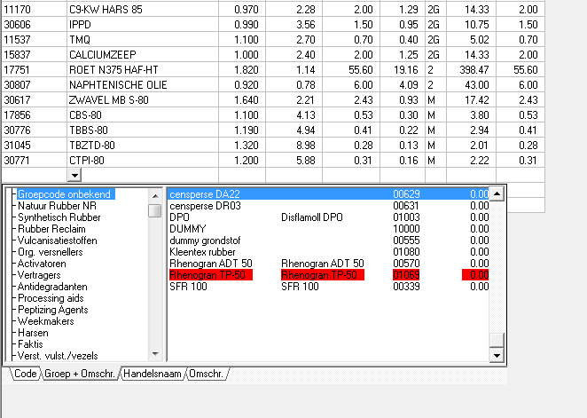

- In Recipes set: Please hide columns Recipe_ID, Recipe_Origin, Recipe Stage, Loadfactor, Mixtime.
- In Recipes set: Please change and fix column order to 1. Recipe version, 2. Recipe_Additional, 3. Descr, 4. Customer, 5. Detailed_Group, 6. Status, 7. Class, 8. Mixer_Code, 9. Created on, 10. Created by, 11. UpdatedOn, 12. UpdatedBy ----→ (We don’t have Customer, CreatedOn, CreatedBy)
- In Recipes set: Please change columnnames Recipe_Origin to Recipe, Recipe_Additional to Add., Descr. To Description, Detailed_group to Group, Mixer_code to Mixer, UpdatedOn to Updated On, UpdatedBy to Updated By.
- In Recipes set: Please change values in UpdatedOn and CreatedOn to date only (not time).
- In Recipes set: The print function does not create a functional/readable table. When printing this table we need on fact only a few columns. Is it possible to select the columns you require and then print? -> Now there are only few columns which are left


- In Recipes set: Regarding the buttons (above): The “Show compared recipes” does not create a functional table. Main function is to create a table in which the first column contains the ingredients and the following columns contain the compared recipes. A picture of the current situation in Eclipse is added.
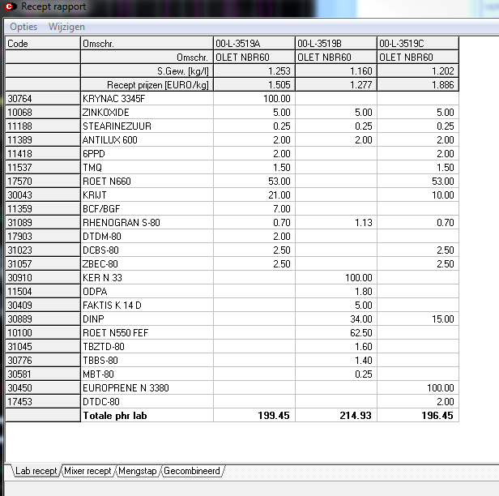

- Regarding the buttons: Deleting a recipe and unblocking a recipe should not be possible here.
- Regarding the buttons: Is it possible to make an export to Excel?
- In INFO: Please rename Notename to Name and Note_Value to Value
- In INFO: Please rename pallete to Packaging, filler to Filler Type, schelflife(weeks) to Shelflife in weeks, packed to Delivery Form, Hardnes ShA to Hardness ShA, recept type to Recipe Type.
- In INFO: How can we add new or rename existing NoteNames and Note_Value?
- In INFO: Please add “IP”, “Polymer Blend”, “Food Grade” and “Approval” as new NoteName
- In INFO: Please change order to Color, Hardness ShA, Recept type, Polymer Blend, IP, Curing system, Filler Type, Approval, Food Grade, Certificate, Shelflife in weeks, Delivery Form, Packaging, Curing System, Industry
- In Sort by Note Value: Upper selector and Sort by Note Value selector are not linked. Is it possible to combine the upper selector and Sort by Note Value into one big selector? → Most likely no
- In Sort by Note Value: Please rename SHELF LIFE 1 to SHELF LIFE MIN., SHELF LIFE 2 to SHELFLIFE MAX., HARDNESS SHA 1 to HARDNESS SHA MIN. and HARDNESS SHA 2 to HARDNESS SHA MAX, FILLER tot FILLER TYPE, RECEPT TYPE to RECIPE TYPE.
- In Sort by Note Value: Please add Polymer Blend, Food Grade and Approval.
- In NOTES: There should be three NoteNames visible: Note, Mixproc and Product. This last one is new. Information in NoteValue will be plain text.
- In NOTES DETAIL: The plain text can be quite substantial. Therefore we need to increase this box. If possible, please decrease the INFO box (smaller columns), move selector to upper part and is it possible to use tabs for the NOTES/NOTES DETAILS (see picture)?
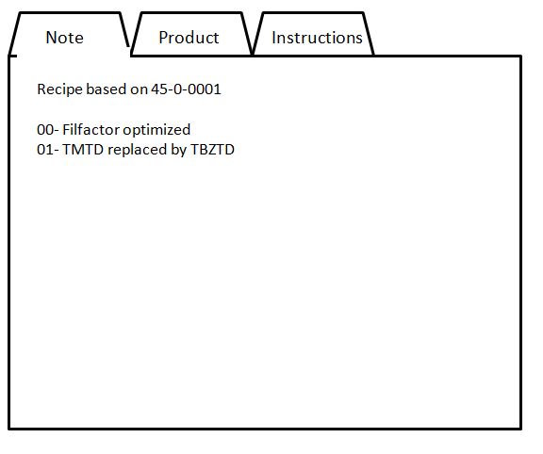

- In RECIPE INITIAL it is possible to change properties. This is not desired. Any change should be made in RECIPE DETAILED. -> You can’t change, the save function is only in “Recipe Detailed Tab”

Requests regarding RECEPT DETAILED:
- Regarding the box RECIPE: In general: Is is possible to hide the value “0” or replace it by “-“? (Not a big issue).
- Regarding the box RECIPE: Please add PRICE/KG and PRICE/L.
- Regarding STATUS: When locked, it should be impossible to change anything. This counts for status S (Active), status O (Old) and the new status Inactive. All need to be unlocked to status I (Unlocked), before change is possible.
- Regarding STATUS: Is it possible to change S to Active, I to Unlocked, O to Old?
- Regarding STATUS: Is it possible to add the value “Inactive”
- Regarding CLASS: Is it possible to to rename P to Production, C to Calculation and R to Development?
- Regarding DETAILED GROUP: Is it possible to add Name and Value together in this field (like AA = NR + IR).
- Regarding DETAILED GROUP: How can we add new Names and Values and how can we change Names and Values?
- Regarding MIXER CODE and MIXER NAME: Is it possible to combine values into one field or if impossible, to hide MIXER CODE and use MIXER NAME only. In this case MIXER NAME should be a picklist. Please change name to MIXER.
- Regarding MIXER CODE and MIXER NAME: How can we add new names and Values and how can we change Names and Values?
- Regarding LOADFACTOR: Please hide.
- Regarding MIXTIME: Please hide.
- Regarding DESCR: Please rename to DESCRIPTION.
- Regarding RECIPE box: Please change sequence to CODE, RELEASE, DESCRIPTION, CUSTOMER, PRICE/KG, PRICE/L, STATUS, CLASS, POLYMER GROUP, MIXER, UPDATED ON, UPDATED BY, CREATED ON, CREATED BY.
- Regarding the buttons general: Please ad a button to LOCK/UNLOCK a recipe (to change from S or O to I and back, or in the newly proposed values from Active, Inactive or Old to Open and back)
- Regarding the buttons: Please add a GO TO button to avoid switching from RECIPE OVERVIEW to RECIPE DETAILED too much
- Regarding the buttons: Is it possible to add buttons to go up and down (versions)?
- Regarding the buttons: Is it possible to add buttons to go forward and backward (recipe origin)?
- Regarding the buttons: Is it possible to add buttons to switch between recipe stages?
- Regarding the buttons: Please add a button to hide/unhide the Price/kg and Price/l (Standard is hide).
- Regarding the buttons: Is it possible to make een export to Excel?
- Regarding the buttons: When creating a recipe from scratch or copying an existing one, please set status automatically to I (open).
- Regarding the buttons: When creating a recipe from scratch or copying an existing one, the action is always followed by clicking the button “Update recipe code” and entering a new code. Can this be done in one go (opening the enter code field when clicking on one of the plus signs)?
- Regarding INFO and NOTES/NOTES DETAIL: Is it possible to put those next to each other instead of above each other. In this case we would be able to visualise much more info.
- Regarding INFO and NOTES/NOTES DETAIL: Same content (changes) as in RECIPE INITIAL and same format for NOTES/NOTES DETAIL box as requested in RECIPE INITIAL.
- Regarding INFO: What is the function of the broomstick button?
- Regarding INFO: How can we change Note_Value here?
- Regarding NOTES: The NoteNames should be fixed, as mentioned in RECIPE INITIAL (Note, Instructions, Product). It might be necessary in the future to add a NoteName, but the standard. Please lets discuss how to do this.
- Regarding NOTES DETAILS: NoteValue need not to be added, but to be changed only. This should only be possible when the status is I (open)
- Regarding RECIPE MANAGER: The number of visible lines should at least be 20, preferably 25.
- Regarding RECIPE MANAGER: What is de function of the Id column. If relevant please rename to ID. Can I use this to manually alter the sequence of ingredients?
- Regarding RECIPE MANAGER: Please rename column name “material” to “Ingredient”, “Descr” to “Destription”, start al column names with a Captiol and replace underscores with a space.
- Regarding RECIPE MANAGER: Please fit column width to field content.
- Regarding RECIPE MANAGER: Please change all fields with numerical values standard to an accuracy of two digits, except for the fields with density. Density should be three digits.
- Regarding RECIPE MANAGER: Please hide columns MatIndex, GRP, percRubber
- Regarding RECIPE MANAGER: Please add columns “% Weight” and “% Volume” (i.e. percentage of ingredient in respect to mass and volume)
- Regarding RECIPE MANAGER: Please change column sequence to ID, Ingredient, Description, Density, Price/kg, PHR, % Weight, % Volume, Loading S., Weighing S, Weight, Density Recalc, PHR Recalc, Weight Recalc.
- Regarding RECIPE MANAGER: The column density_Recalc is not relevant. Only the recalculated final value. Is it possible te hide the column but show the final value somewhere?
- Regarding RECIPE MANAGER: the columns/fields with numerical values should be filled out to the right (all comma’s lined out vertically)
- Regarding RECIPE MANAGER: The separate row (bottom line) seems not to be linked when moving columns. Also some info is not relevant ->????
- Regarding buttons of recipe manager: Changes should only be possible when the recipe is “unlocked”. -> You can calculate or do something but no changes can be saved for a disabled recipe
- Regarding RECIPE MANAGER: The sequence of ingredients should not be automated in any way. We prefer to use the ID sequence to arrange this manually. If possible of course.
- Regarding RECIPE MANAGER: We need not only to add or delete an ingredient, but also to change several parameters of an existing line (ID, Ingredient, PHR, Weight, Loading S. and Weighing S.)
- Regarding RECIPE MANAGER column Description: When using a recipe as ingredient (masterbatch), the Description is left empty.

